**TEAMCENTER POLARION INTEGRATION**

**Prerequisites:**

* Install Polarion 2304
* Teamcenter deployed Four Tier Installation- 14.3
* Install Active workspace-6.3
* Download **Teamcenter polarion integration 4.3.1 zip file** on Gtac support

After downloading the Teamcenter connector (Teamcenter polarion integration 4.3.1 zip file**). Then** Extract the Zip file in this directory

**[C:\Polarion\polarion\extensions]**

Restart Polarion

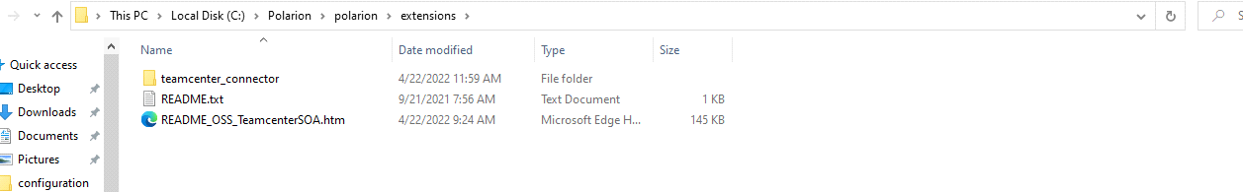

* Administrative access to Teamcenter.
* **Install Teamcenter Linked Data Framework on Teamcenter**
* Administrative access to the server running Polarion
* Polarion accessible from Teamcenter.

Go to polarion.properties file [C:\Polarion\polarion\configuration]. Check the **base.url** parameter. It must be fully qualified domain name, and it doesn’t include the default port or **localhost:80**

**Example** [**http://denbg0415vm.izd01.in**](http://denbg0415vm.izd01.in/)

**1) Install Linked Data Framework on Teamcenter:**

Linked Data Framework Installation Checklist

Install all this feature on Teamcenter Environment Manager:

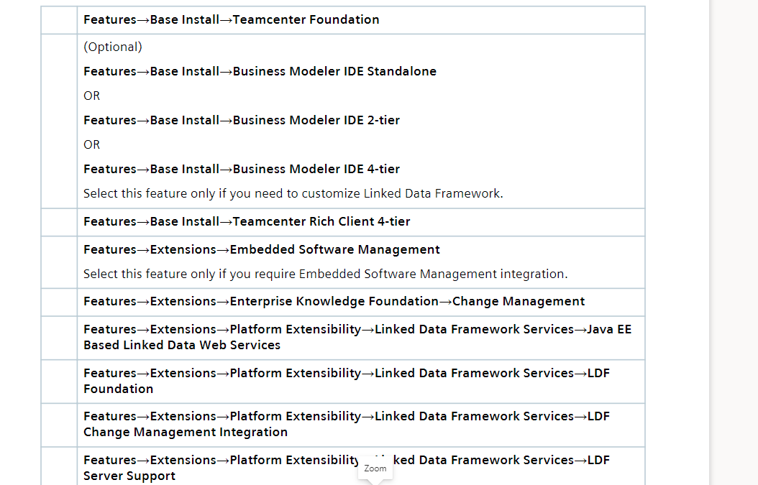

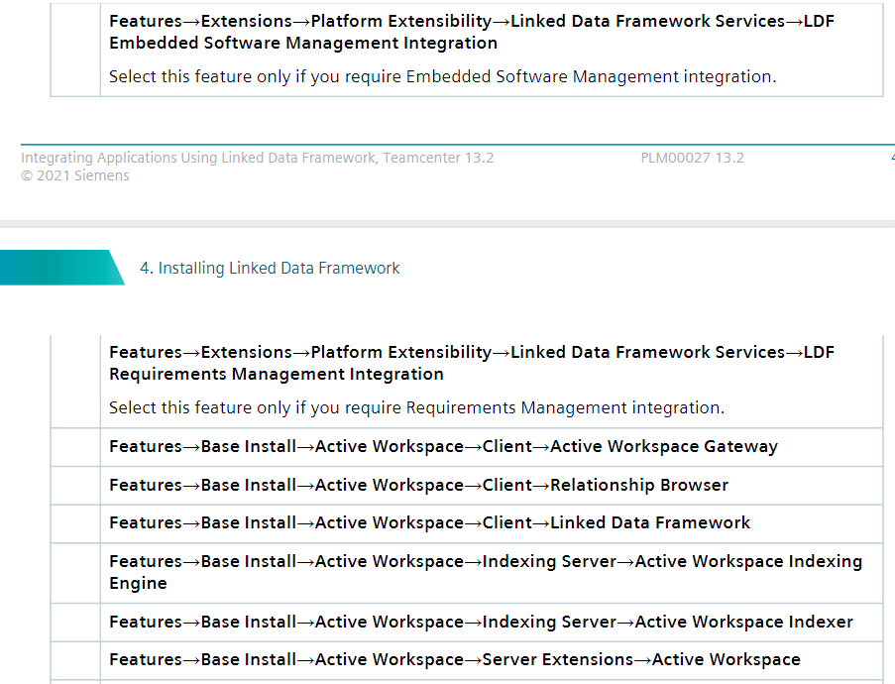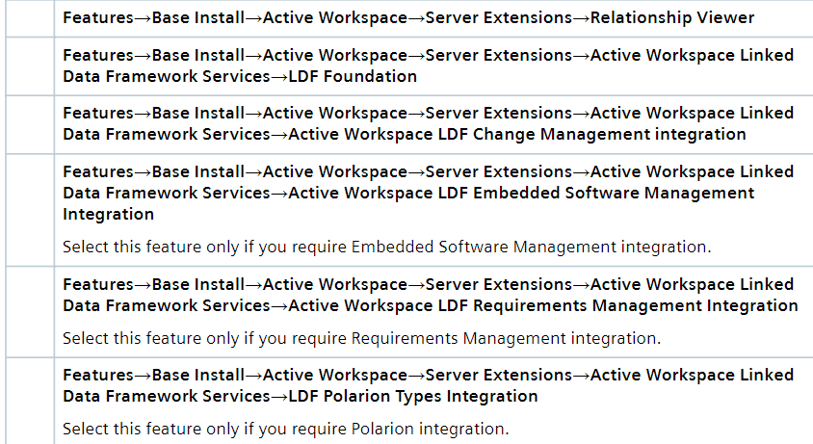

**Note**:Install Linked Data Framework Associated by **Paul prasanth**

**2)Deploy Linked Data Framework:**

After Installing Linked Data Framework using TEM you must deploy the lis.war file to a j2EE web based application server.

The lis.war file is located at TC_ROOT Directory [**D:\TcFile\TcRoot\lis\stage\lis]**

Before You deploy the lis.war file on your server:

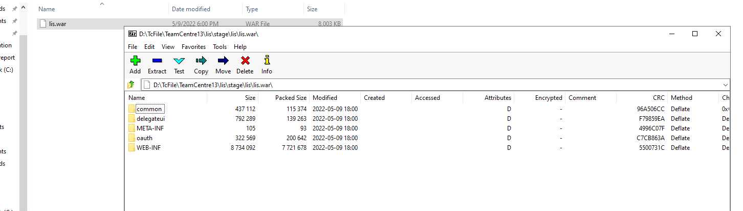

1)You update the web.xml file and add the Following content

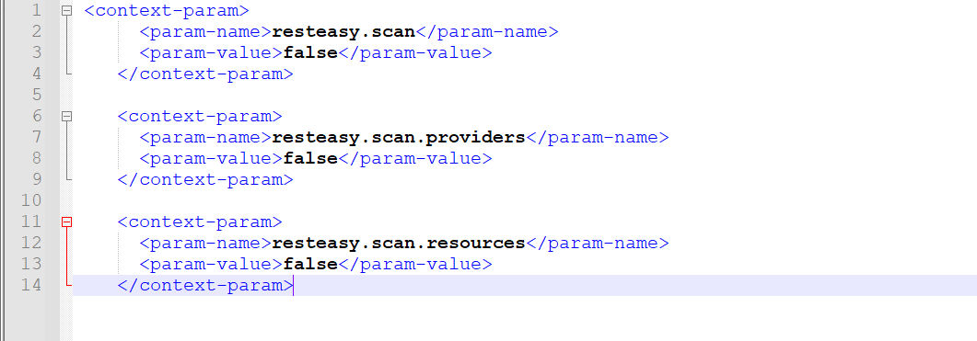

2)create a new xml file in the name of jboss_deplyment_structure.xml in inside the WEB-INF Directory and paste the following code

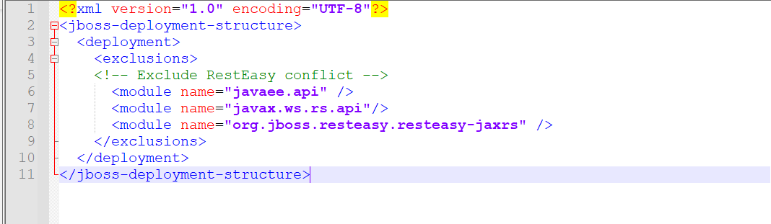

3)If we are using jboss server you comment below dependency in standalone .xml file

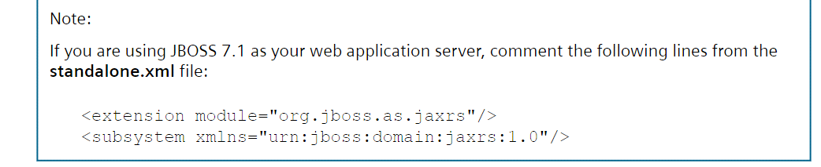

4)Add the Lis path in config.json file

D:\TcFile\TcRoot\microservices\gateway-1.5.0

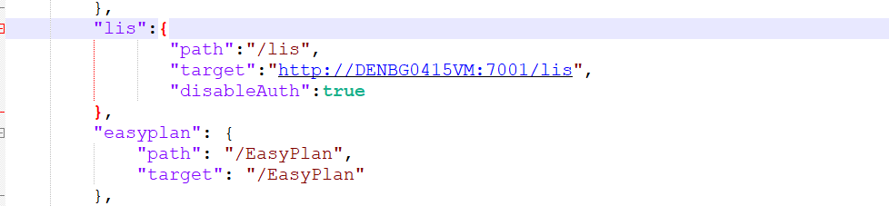

Then deployed lis.war file and check all services was started

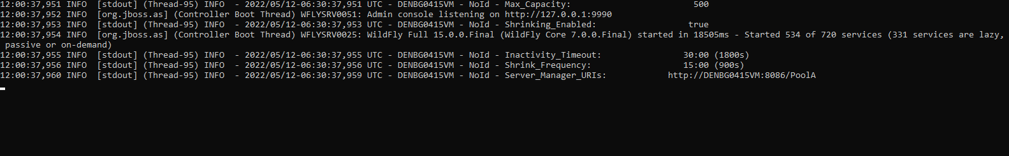

**Note**:Deploy Linked Data Framework Associated by **paul prasanth**(Intelizign)

**3)**Verify linked data Framework installation is sucessful1

If You deployed lis.war file properly

You are able to access the linked data Framework root services.

Otherwise, we can’t be able to access the root service url

Example: Root service url Format [**http://denbg0415vm.izd01.in:3000/lis/oslc/rootservices**](http://denbg0415vm.izd01.in:3000/lis/oslc/rootservices)

After load the url you get the root service document means your lis service is working good

**3) Configuring Linked Data Framework on Teamcenter**

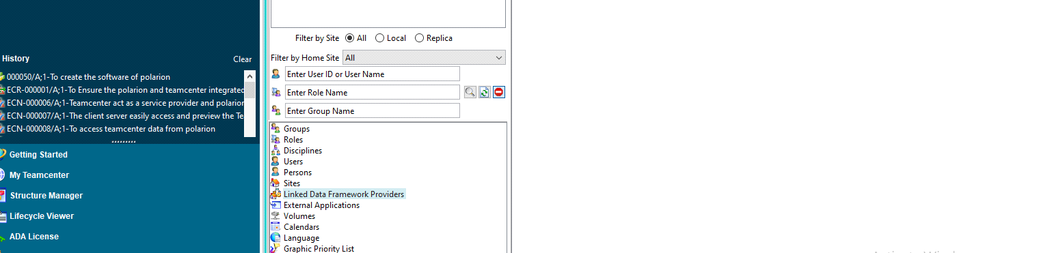

We configure Linked Data Framework on Teamcenter Rich client

1)Goto ->organization List->select Linked data Framework Providers

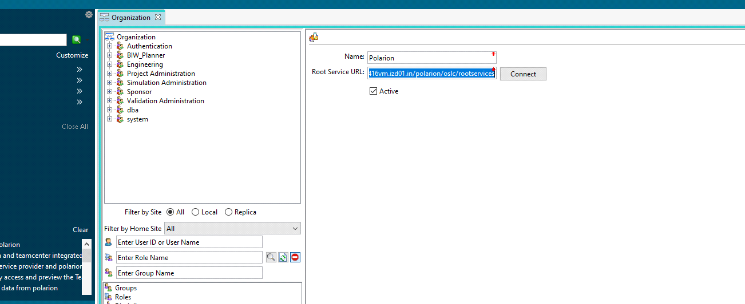

Here **polarion acts as a provider** it allows the teamcenter to access its Polarion service

And Teamcenter act as a consumer

2)Type a name for the site in the name box(Polarion)

3)Add provider root service url(Polarion root service url)

Example:[**http://denbg0416vm.izd01.in/polarion/oslc/rootservices**](http://denbg0416vm.izd01.in/polarion/oslc/rootservices)

Click the **connect** button

If the connection is sucessful and if the site supports OAuth the OAuth boxes appear

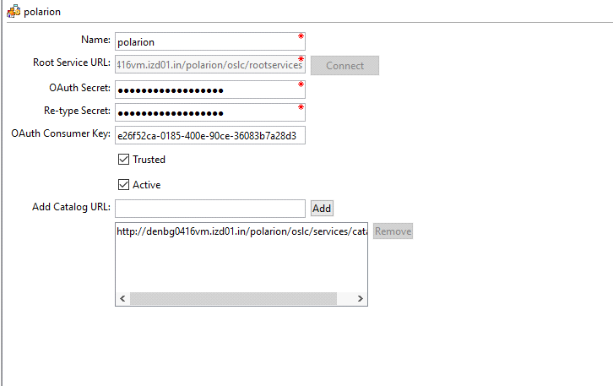

4)Type the secret Phrase in **OAuth secret box**.The secret phrase can be any text

5)Type the secret phrase the one you provided above again in the Re-type secret box

6) (Optional) Type the **OAuth consumer key** in the OAuth Consumer Key box. If this box is left blank, Teamcenter automatically generates a consumer key.

7)select the **Trusted** Check box

8)select the **active** check box

9) provide a path to the catalog that contains services this site provides by adding the catalog URL to the Add Catalog URL list.

10)click create to create a **Linked Data Framework site**

**Add Service Provider:**

1)click add service Provider button then polarion login window appears.It asks teamcenter access polarion service

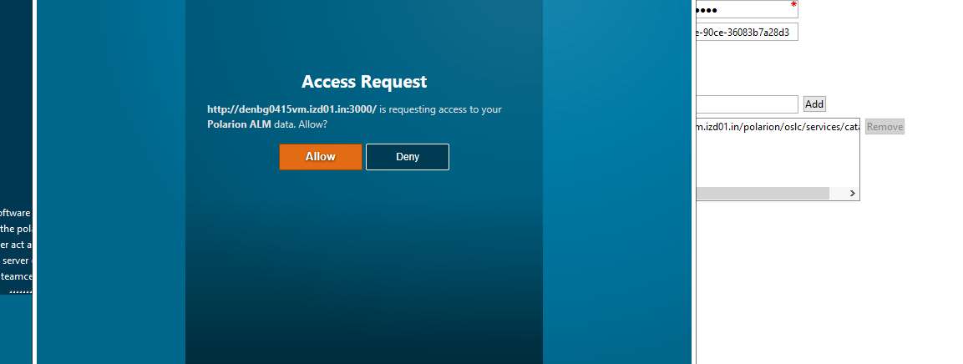

Give allow now Teamcenter able to access Polarion service

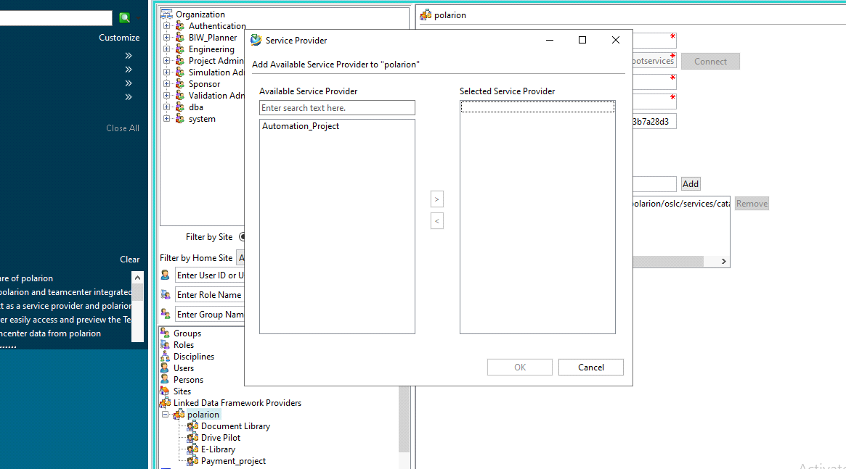

2)In the **Service Provider dialog box**, select the service provider you want to add from the **Available Service Provider** list and add the service provider to the **Selected Service Provider list.**

3)To ensure that these semantic relations are available when you create Linked Data Framework links, you must add the semantic relations that you want to use for each service provider as follows:

4)In the **semantic List** click **Add/remove Button**

5) In the **Semantics dialog box**, select the semantic relations you want from the Available **Semantics list** and add them to the **Selected Semantics** list.

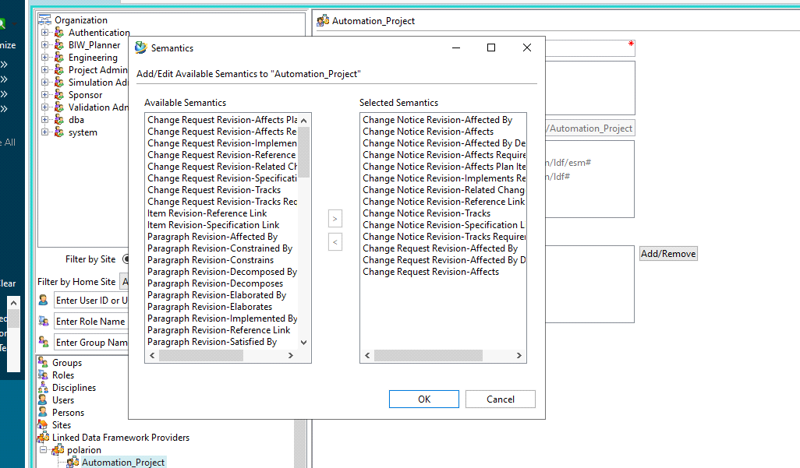

6)click **ok**

7)click **Modify**

Note:**Configuring Linked data Framework on Teamcenter** Refer to the siemens Documentation(Linked Data Framework Documentation)

<https://iz-my.sharepoint.com/:b:/g/personal/divakar_r_intelizign_com/EZizts2afVNOkzDqk6ip5QgB3dnSo7IAHpOjRZCuUGOlqQ>]

**4) Update to new linked data Framework relation:**

After you upgrade to Teamcenter version 11.4 or later, you must run the **migrate_relations_to_ldf** utility to ensure that the correct relations appear in Relations Browser.

This utility updates the **IMAN_reference** and **IMAN_specification** relation types that are used to associate Linked Data Framework links as a secondary object to the **Lis0Reference** and **Lis0Specification** relations, respectively.

**5)Update the semantic mapping property files:**

After upgrading your Teamcenter and Linked Data Framework installation, you must update the **semantic mapping property files**, if you modified those files.

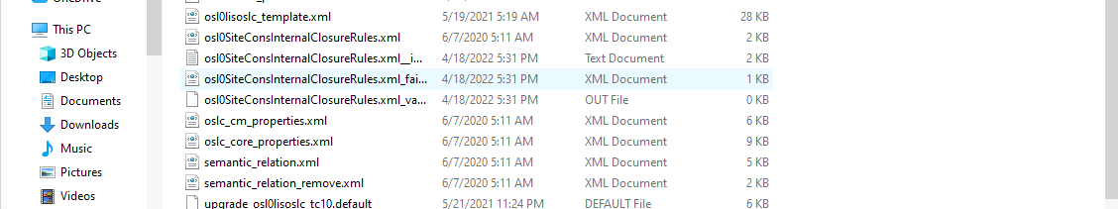

To update these Files:

* **Oslc_cm_properties.xml** located in [D:\TcFile\TeamCentre13\install\osl0lisoslc]
* **Oslc_core_properties.xml** located in [D:\TcFile\TeamCentre13\install\osl0lisoslc]

1)Take a backup of these Files

2) After you upgrade your Teamcenter and Linked Data Framework installation, run the **create_botype_reader** utility with the following arguments:

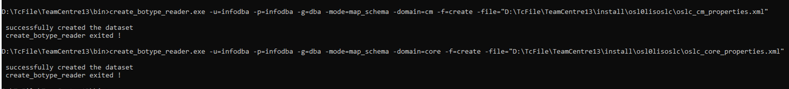

**6)Set Preference:**

Create a preference named **ActiveWorkspaceHosting.Lis.Url** and update the value is

Example:[**http://denbg0415vm.izd01.in:3000/tc.html?ah=true**](http://denbg0415vm.izd01.in:3000/tc.html?ah=true)

Create a preference named **TC_LDF_host_url** and update the value is

Example: [**http://denbg0415vm.izd01.in:3000/lis/**](http://denbg0415vm.izd01.in:3000/lis/)

Create a preference named **LDF_FQDN** and specify the fully qualified domain name of the machine where Linked Data Framework is deployed as the preference value.

Example: .**izd01.in**

**Note:**

* Ensure that the URL has the suffix **?ah=true**. For example [**http://denbg0415vm.izd01.in:3000/tc.html?ah=true**](http://denbg0415vm.izd01.in:3000/tc.html?ah=true). This suffix is required for Active Workspace delegated UIs to work properly.
* Ensure that the URL uses hostname and not IP-based URLs. Linked Data Framework does not support IP-based URLs.

**Note**:**Set preference in Teamcenter** Thin client Associated by **Nagraj Rajasekar**

**7)Configure Relations tab to show Linked Data Framework objects and relations:**

The Relations tab in Active Workspace allows you to view the relationship between objects in Teamcenter. You can also configure it to show relations between **Teamcenter objects** and objects in an **external or remote application** such as **Polarion.**

**Note**: Go through siemens Linked data Framework documentation

8)**Migrate the workflow handler reference from p2-create-work-item-lis-link** to **LDF-create-object** by doing the following:

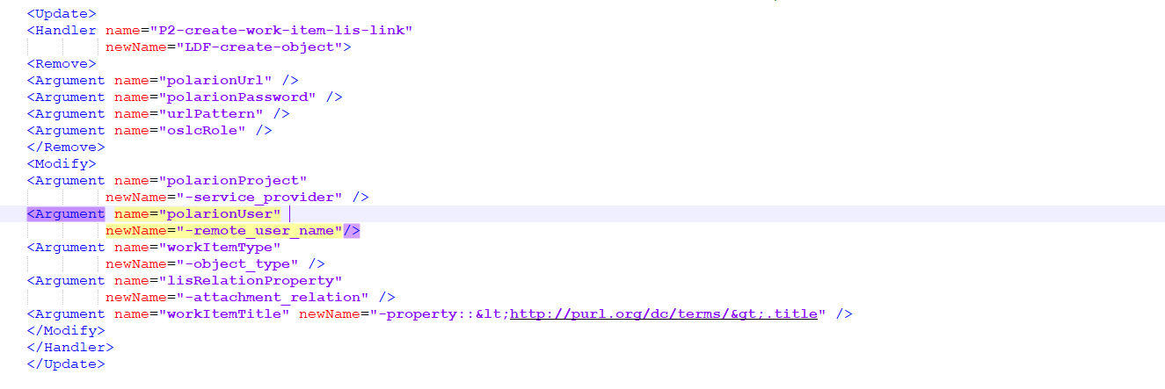

Add this content in **wf_handler_migration.xml** is Present in this directory[D:\TcFile\tc data]

1) Run the **migrate_wf_handlers** utility to migrate P2-create-work-item-lis-link **handler references.**



**Note**:Run the **migrate_wf_handlers** Associated By **Divakar**

**To access Polarion Data Inside the Teamcenter Thin client and linking polarion workitem from Teamcenter Thin client**

1)Login Teamcenter Thin client [AWC]



2)Open the Teamcenter Item Revision and click the **Refrence items** tab

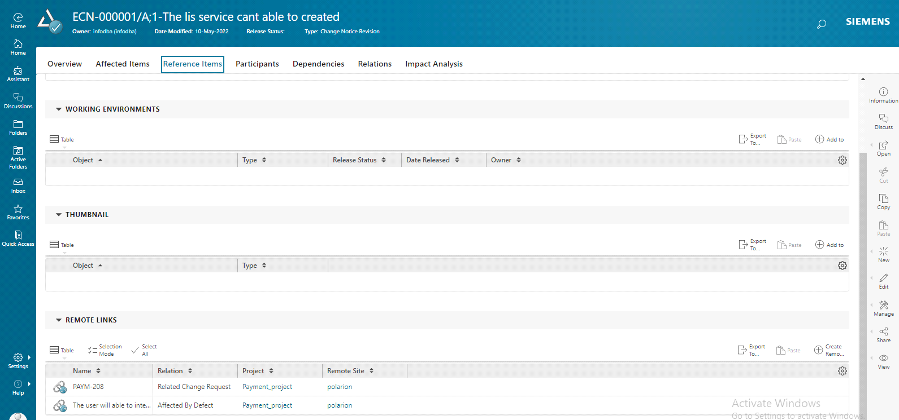

3)Click the **create Remote Link** In Bottom Right Corner

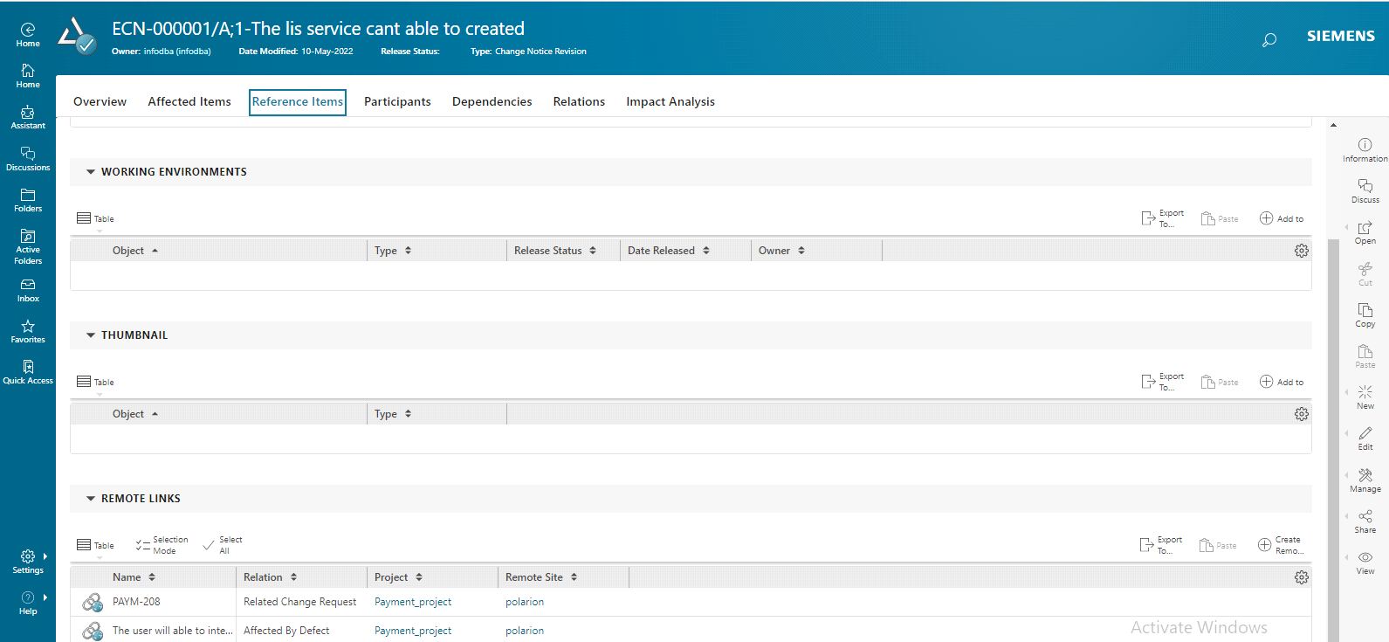

4)After click create Remote Link then one **dialog box** appear here we choose your **polarion project**

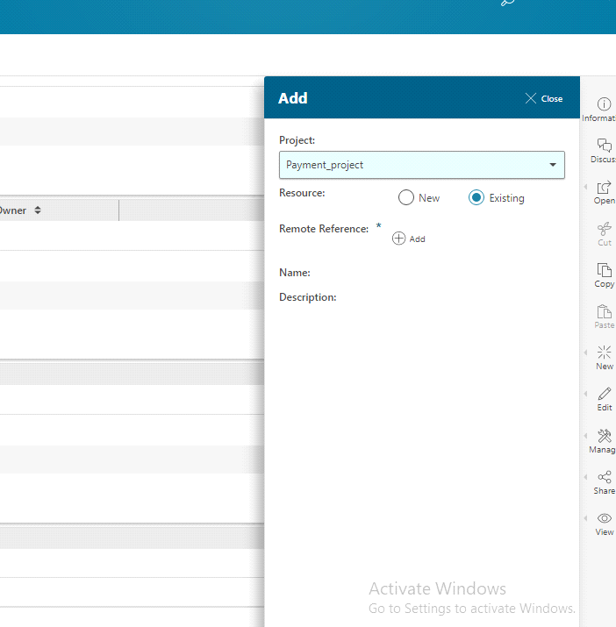

Here two option is there one is **Existing resources.**

1)You select the Existing resources means

You can able to link the Teamcenter Item From already Existing WorkItem(Resources) In your Polarion Project

2)You select the **New Resource** Means

You can able to create one **New workitem**(resources) in you**r Polarion Project.**Then Workitem was created after we link the Workitem to in your **Teamcenter Item**

5)Click **Add** .Then appear **Polarion Login Page** .Login with your credential

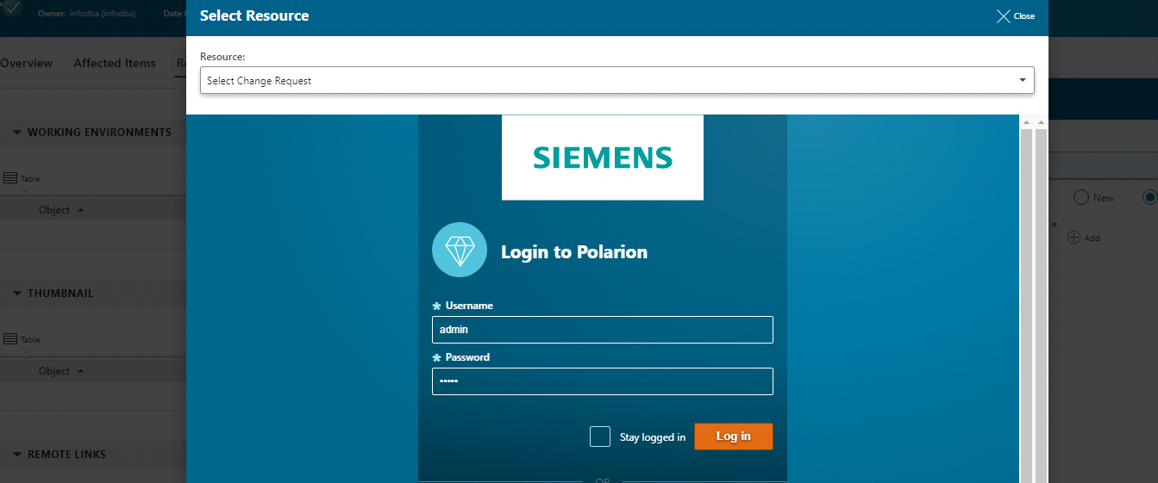

6)After open Polarion Inside the Teamcenter Thin client there List out all resources(workitem) You select the Existing Resources(WorkItem)

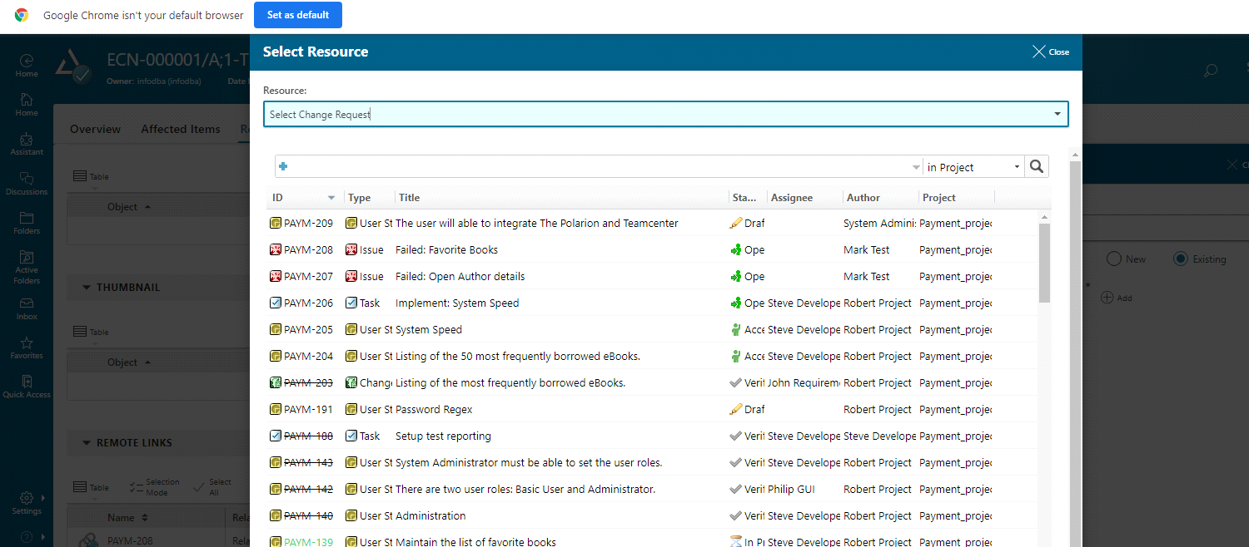

7)After select the workitem is add on your Teamcenter Thin client

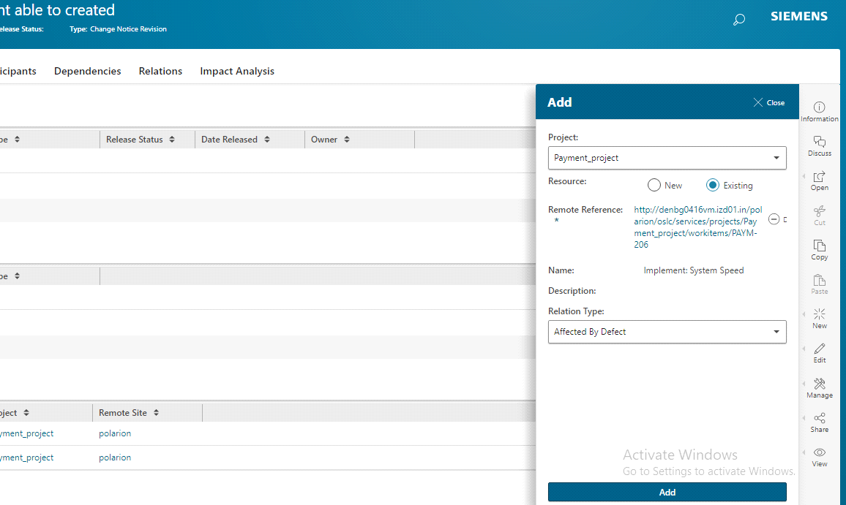

8)Click **Add** Now the Polarion WorkItem Is SucessFully Linked in Your Teamcenter Item

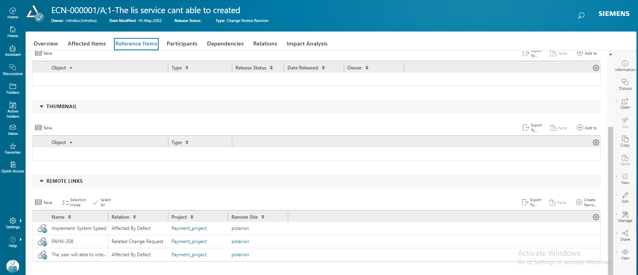

Here **Implement system speed** workitem is sucessfully linked in your Teamcenter item Then open the Workitem You can able to access the Polarion WorkItem Inside The Teamcenter Thin client

9)Open the Polarion workitem Inside the Teamcenter Thin client and check it out

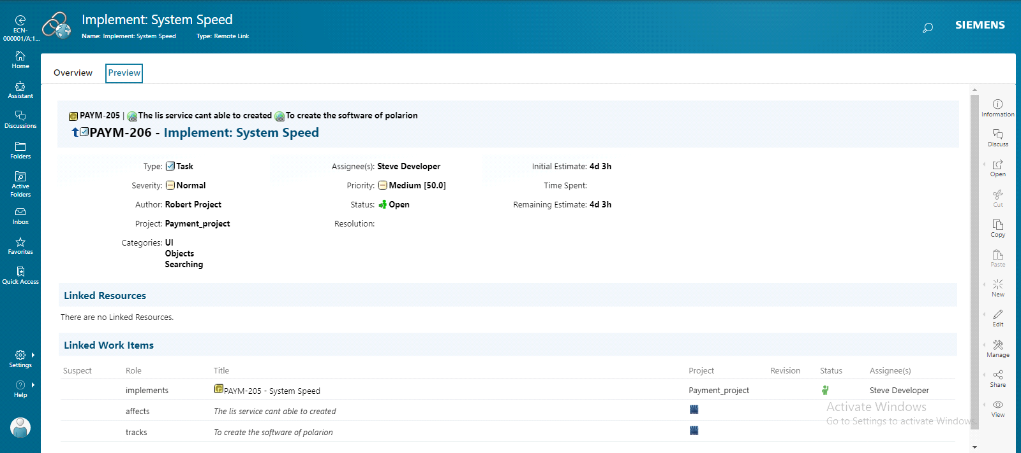

**Note:**To access Polarion data inside the Teamcenter Refer to the siemens Teamcenter_Polarion_Integration Documentation)

**Configure Linked Data component In Polarion and Add Teamcenter as Friend as Polarion:**

Polarion Linked Data is an integration framework that allows you to integrate Polarion with different applications or enterprise information systems. Using data linking, you can create relations to resources in remote applications without copying data.

By configuring the Polarion Linked Data component to utilize Teamcenter data, Polarion users are able to create LDF links to existing or new Teamcenter Items. Polarion users are then able to preview and even modify the linked Teamcenter items.

**The configuration process consists of two steps**:

1. Add the Teamcenter server as a provider for Polarion LDF.

2. Enable the linking of Polarion Work Items to Teamcenter Items.

Add Teamcenter Server as a provider for Polarion Linked Data

First, add your Teamcenter server to Polarion as an Linked Data Friend.

1. In Polarion, click on the top left of the Navigation bar.

2. Click **Administration.**

3. Click **Global Administration**

4. Click the **Linked Data** topic on the Navigation.

5. Click the **Linked Data Friends** subtopic.

6. Click 

7. The following dialog appears.

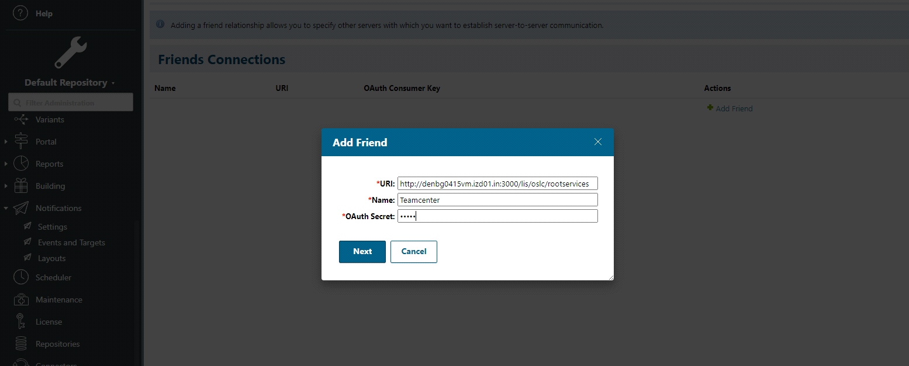

1)Give Teamcenter Root service Url

Example:**http://denbg0415vm.izd01.in:3000/lis/oslc/rootservices**

Here Polarion acts as a **consumer** and Teamcenter acts as a **Provider**

Teamcenter allows polarion to access its Teamcenter service

2)Name as Provider Name(**Teamcenter**)

3)Type any secret Phrase in The **OAuth secret box**

4)CLICK **NEXT** then Teamcenter login page open inside the Polarion and give Teamcenter login credential

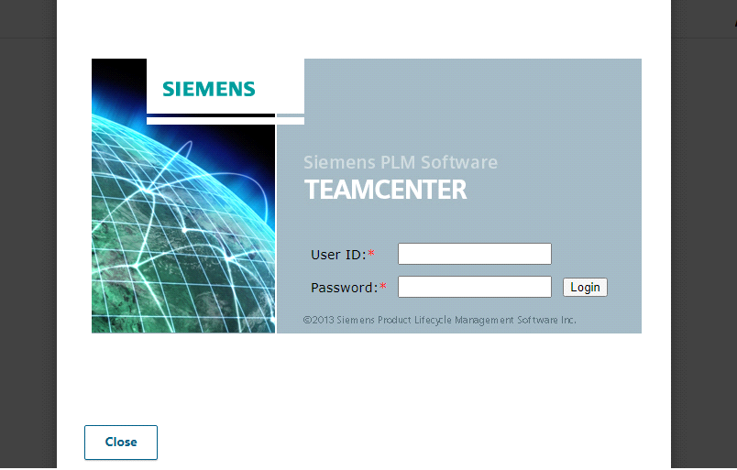

5)After another one dialog box open there you give this polarion consumer to access teamcenter data

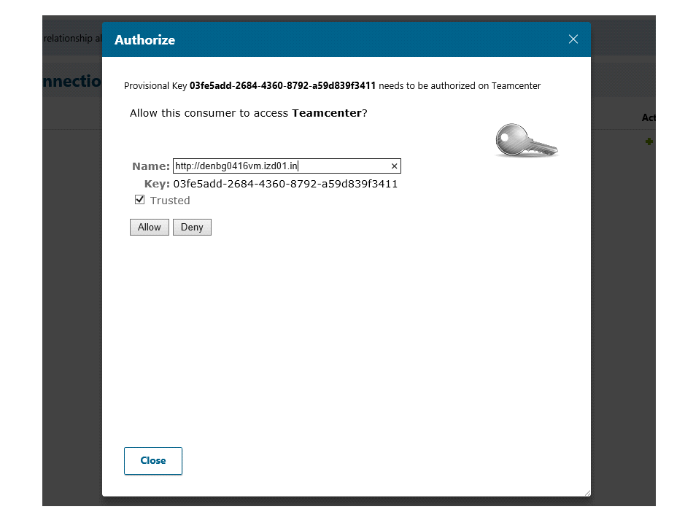

6)In the Name Text box you give your polarion server url

7)And selected The **trusted** checkbox

Give **allow** and close the dialog box. After **Teamcenter server** add as Friend as **Polarion.** Now the Polarion consumer able to access Teamcenter Data

**Note**:Associate by **siemens support center**

Enable the linking of Polarion Work Items to Teamcenter items:

After adding Polarion as a friend to Teamcenter, you can enable the linking of Polarion Work Items to Teamcenter items by adding an association to Teamcenter in project **Administration**.

1. Open Polarion project Administration. You are probably in Polarion's **Global Administration**. To switch to the Project Administration, click the arrow next to the name of the current repository,and choose your project.

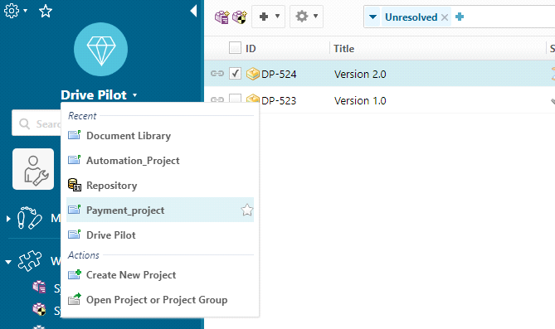

2. Click Linked Data→**Linked Data Associations.**

3. Click.

4. In the Add Association box, add the required data:

•Friend: Select the Teamcenter server that you want to connect this Polarion project to.

5. If you are connecting for the first time during this session, a dialog box opens with the ActiveWorkspace sign-in page. Enter valid DBA Teamcenter credentials (any DBA account).

6. After entering the credentials, you will be returned to the **Add Association dialog**.

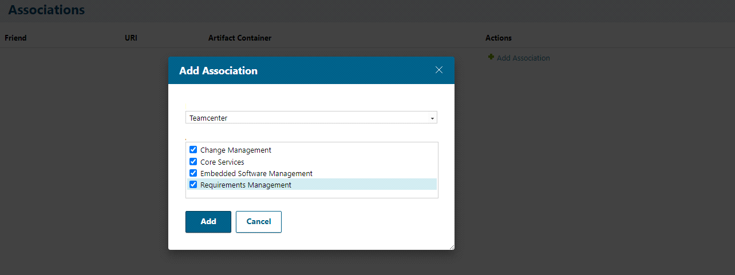

• Select **Change Management** if you want to link to Teamcenter items specific to Change Management (for Example: PR, ECR, ECN).

• Select **Core Services** if you want to create generic links to any Teamcenter item type.

• Select **Embedded Software Managemen**t if you want to link a release in Polarion to Teamcenter

• Select **Requirements Management** if you want to link to Teamcenter requirements.

**NOTE**:

To select all service then you can able to access all Integrate Function

Configure The WorkFlow In Polarion

All automatic operations between Teamcenter and Polarion are done through workflows.

This enables the creation of integration workflows in Polarion. An integration workflow executed in Polarion automatically creates new Teamcenter items and LDF links to those items.

**To create a Teamcenter object as part of executing a workflow action**:

1. In the project's Administration topic, open **Work Items→Workflows.**

2. On the Work Item you want to modify the workflow for, click **Create** if there is no custom workflow in place, or **Edit** to edit the current workflow.

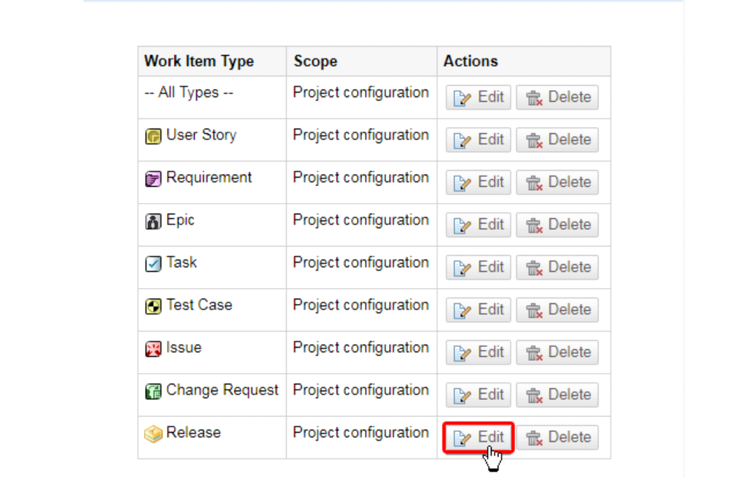

3) Go to **Actions,** enter an **ID**, Name and click .

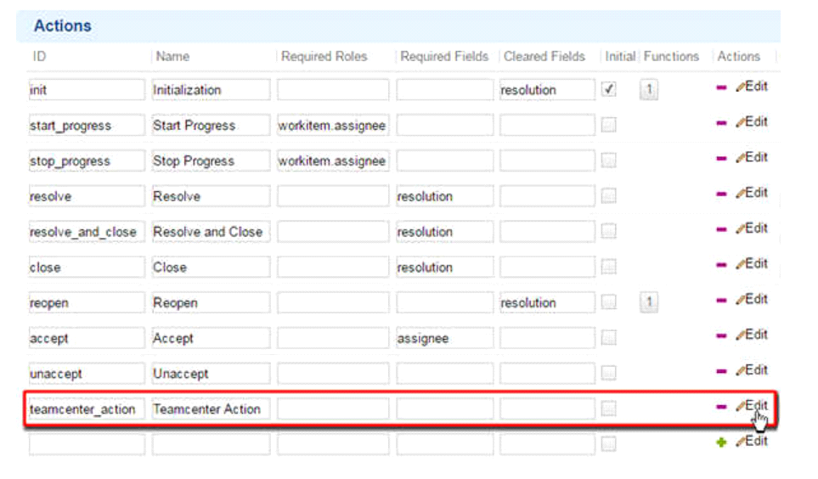4. Click **Edit** beside the newly created action.

5. In Functions, select **CreateRemoteObject** from the drop-down menu and click

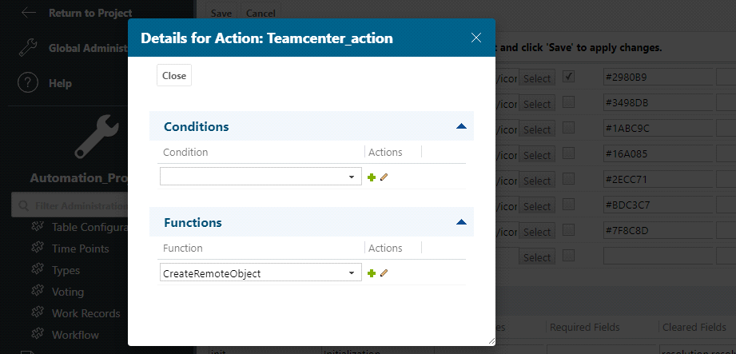

**Note:**

You must add this function to every workflow Action that will **create an object** in **Teamcenter**.

6. Click on the beside CreateRemoteObject and add the following Required parameters: **Required and Optional Parameters**:

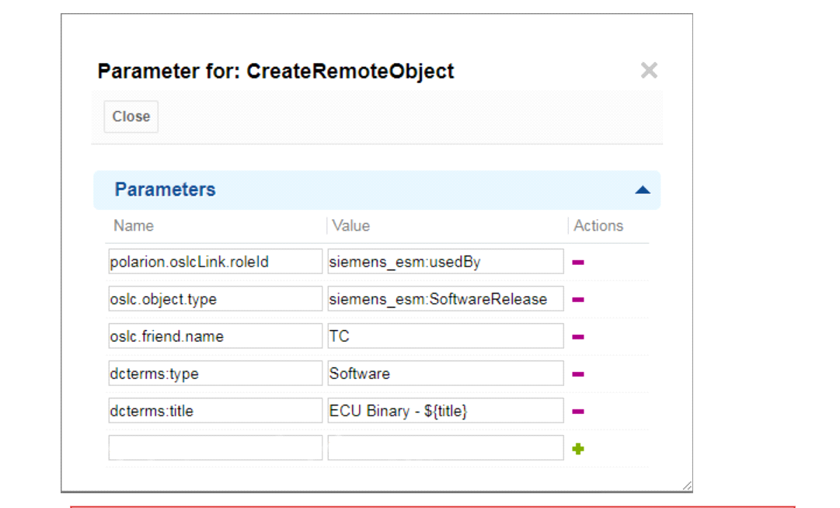7. Close () the Parameter for: dialog when all of your Parameters have been defined and click Save.

**Note**:**Configure the Workflow in polarion** Refer to the siemens Teamcenter polarion integration Documentation

**To access Teamcenter Item Inside the Polarion and Link a teamcenter item from a polarion work item:**

1. In Polarion, select the Project.

2. Click Work Items in the navigation bar.

3. Select an existing Work Item or create a new one.

4. Scroll down to the section.

5. Click the blue  or to the section.

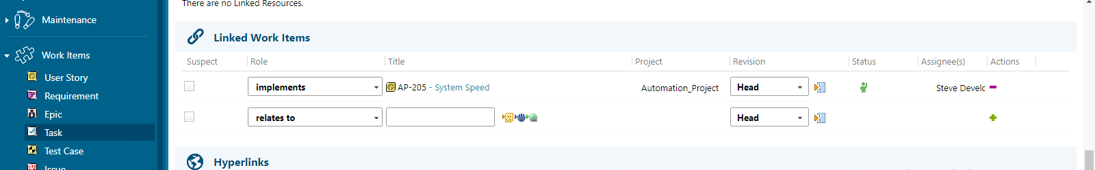

6. If you have associated an Linked Data artifact container with the current project, you see a icon.

**NOTE:**

Once Linked Data Friends are configured by an **administrator**, they appear as an  icon in the Linked Work Items section of a Work Item.

7) Click the  icon

**Note:**

If the is greyed out, the link role has not been mapped in Polarion.

8. The **Link External Item (Linked Data**) box appears.

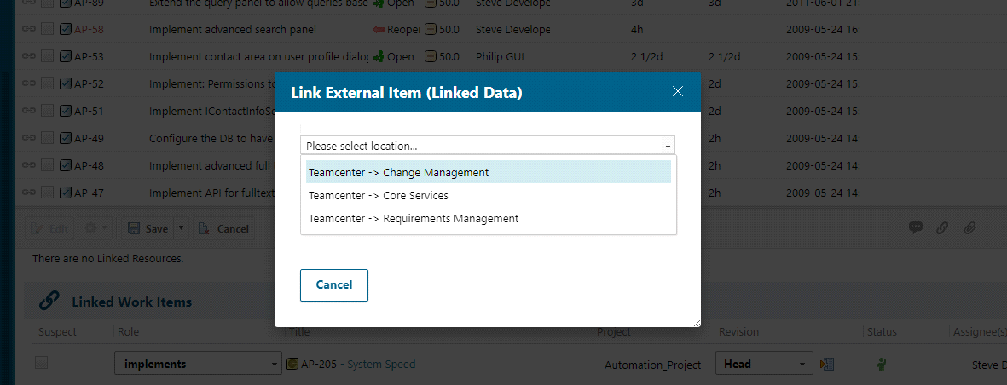(Polarion will automatically filter out options that aren't applicable for the selected role.)

9. Select the Teamcenter service from the drop-down list.

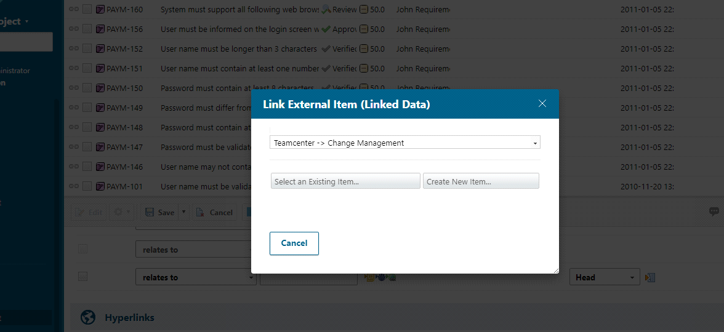

After selecting the services in the drop down it asks **select an existing item** and **create new item**

* There are two option is there you can select and **existing item** means you can able to link the Existing Teamcenter item to your Polarion WorkItem
* You select **create New Item** means you can create one new Teamcenter item after created the item will be able to link your polarion work item

10)Select **Existing Item**(**To Link Existing Teamcenter item to your Polarion WorkItem**)

a)You click select Existing Item Then Teamcenter client open inside Your Polarion tool:

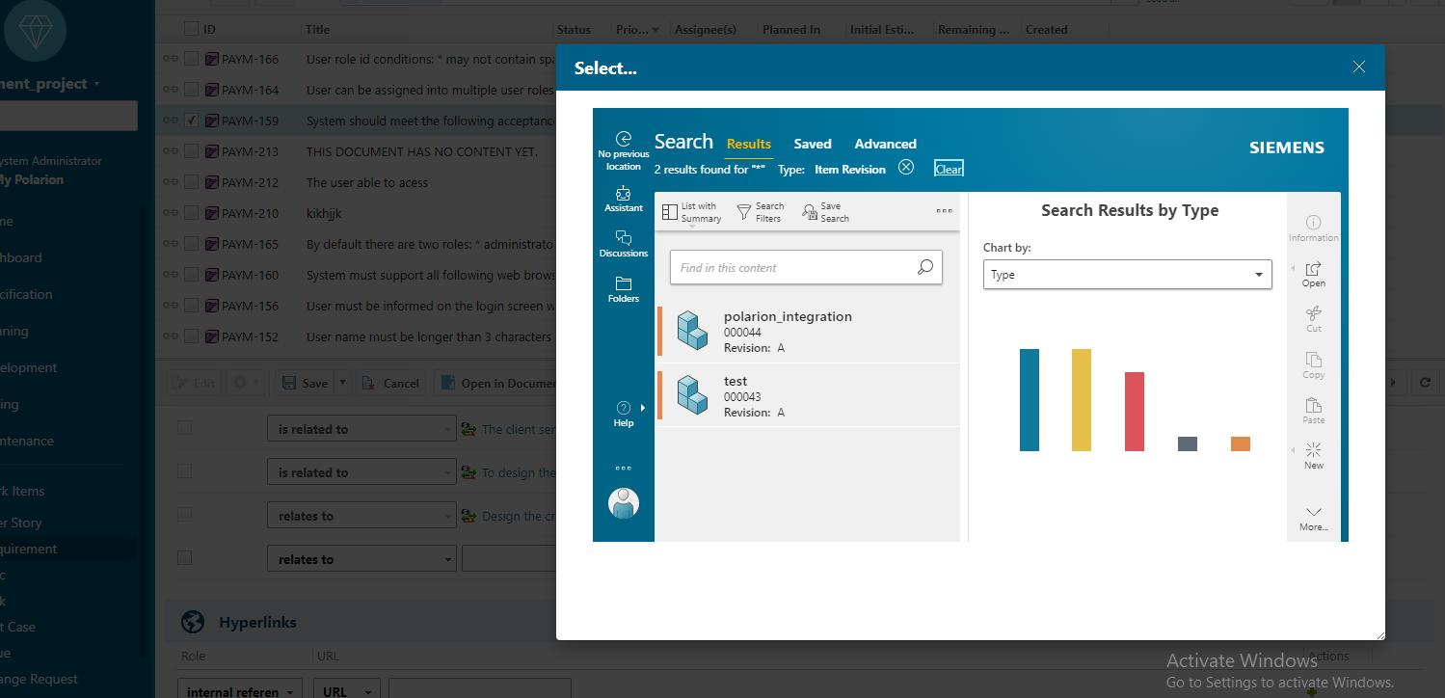

b)In the Teamcenter client select the item (Polarion_integration item) and click **ok**

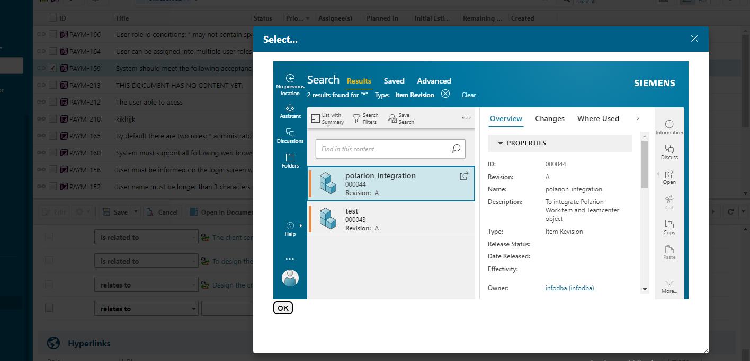

c)Now the teamcenter item is sucessfully linked in your Polarion work item

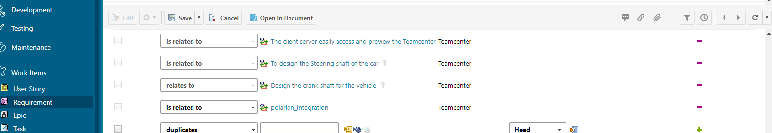

d)Click **SAVE**

11))Select **create New Item(To create New item in Teamcenter and that item linked in your polarion workitem)**

a.) Create **New Item** to access the Linked Data application **Creation dialog box**, then provide the requisite Teamcenter Business Object creation parameters and click Add.

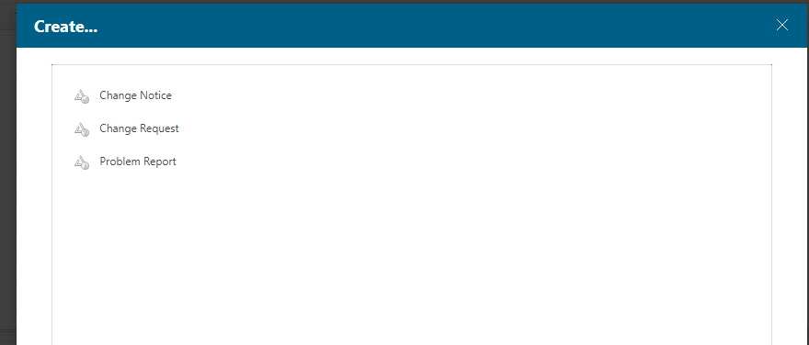

b) Click the item type

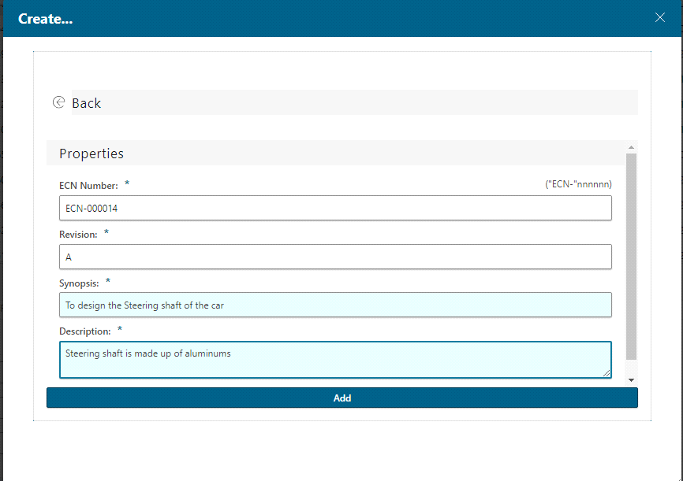

c)Click **Add.** Teamcenter item is created and is linked to your polarion work item

d)**Save** the changes

11) Now the New **Teamcenter item** is created and its **sucessfully Linked** To your Polarion WorkItem

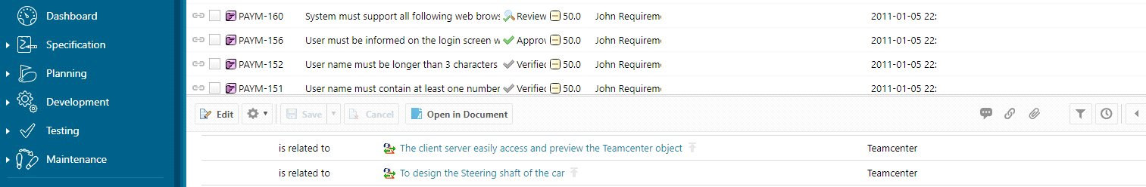

12)Then You can able to access The Teamcenter data inside the Polarion.

Click the linked **Teamcenter item** and check it out

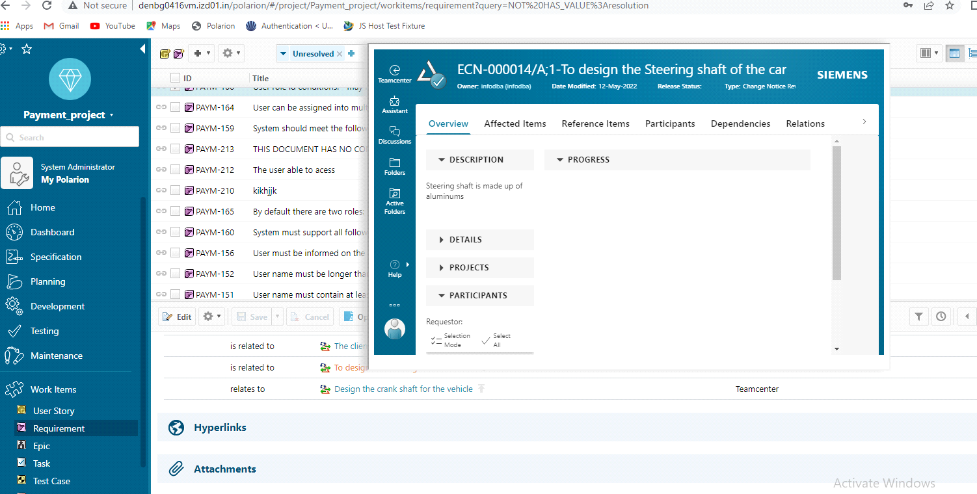

Then go to Teamcenter Thin client and we can able to view the linked polarion workitem

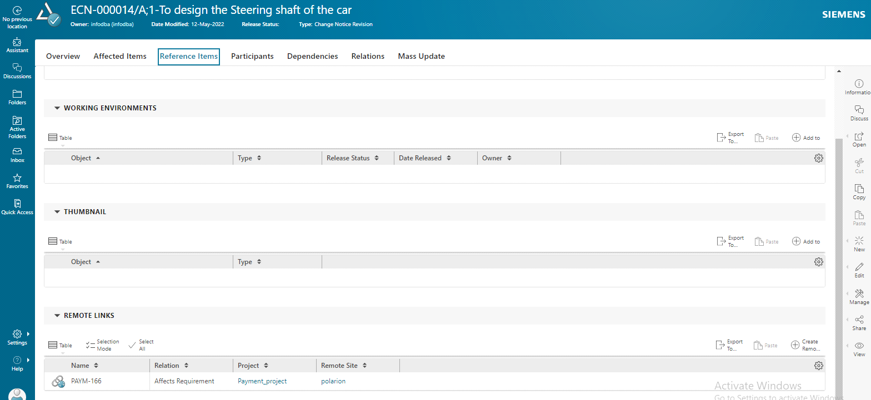

In Teamcenter thin client we able to view the Polarion workitem and created Teamcenter item is also Linked and see the below pic 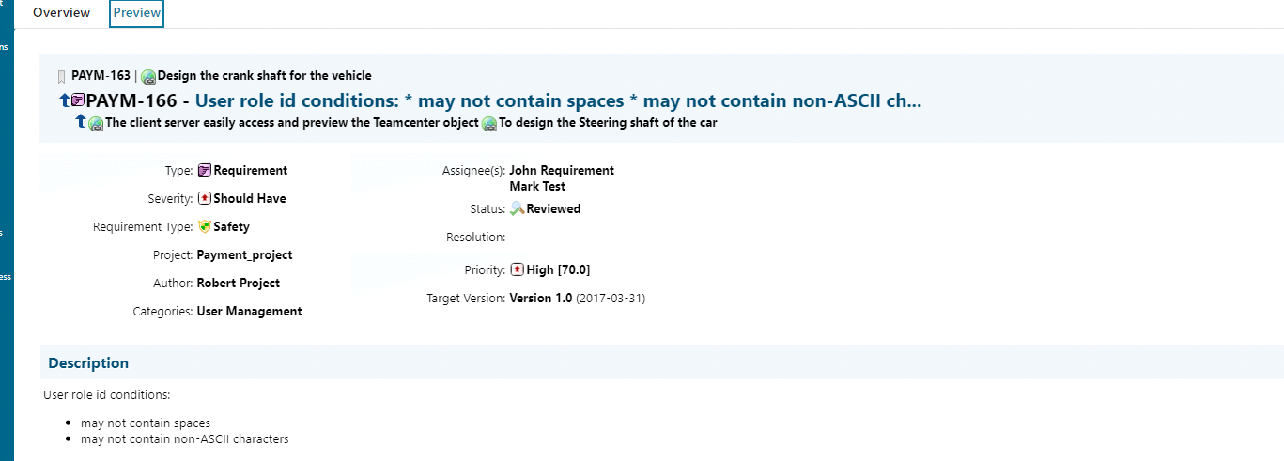

In this Integration using Linked data Framework you can able to access the Teamcenter data inside the Polarion and same as access the polarion data inside the teamcenter we can also Modify the data

NOTE:To acess Teamcenter inside the Polarion Refer to the siemens Teamcenter polarion integration documentation)

**Links:**

**Siemens Teamcenter polarion integration Documentation**

<https://iz-my.sharepoint.com/:b:/g/personal/anurag_pradhan_intelizign_com/EZXmPZl-X4pOttIry7nDXY0BtGbYi6FpazgPVtLqmiZn_A>

**Siemens Linked Framework Documentation**

<https://iz-my.sharepoint.com/:b:/g/personal/divakar_r_intelizign_com/EZizts2afVNOkzDqk6ip5QgB3dnSo7IAHpOjRZCuUGOlqQ>